**Project Design Phase-II**

**Technology Stack (Architecture & Stack)**

|  |  |
| --- | --- |
| Date | 21 October 2022 |
| Team ID | PNT2022TMID03634 |
| Project Name | Project - **Smart waste management system for metropolitan cities** |
| Maximum Marks | 4 Marks |

**Technical Architecture:**

The Deliverable shall include the architectural diagram as below and the information as per the table1 & table 2

**Example: Order processing during pandemics for offline mode**

**Reference:** [**https://developer.ibm.com/patterns/ai-powered-backend-system-for-order-processing-during-pandemics/**](https://developer.ibm.com/patterns/ai-powered-backend-system-for-order-processing-during-pandemics/)

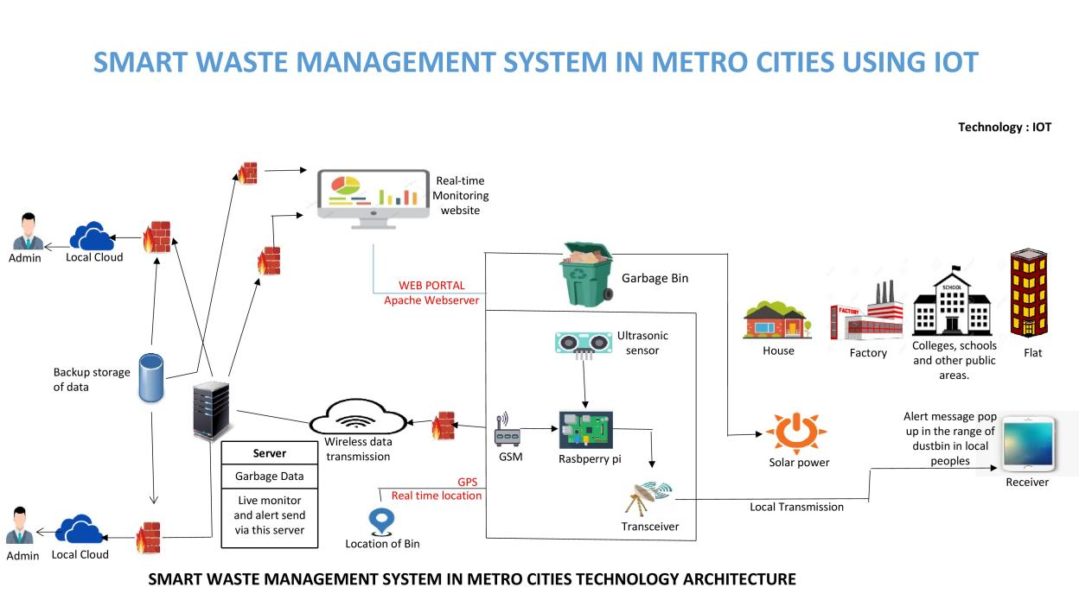

Guidelines:

1. Include all the processes (As an application logic / Technology Block)
2. Provide infrastructural demarcation (Local / Cloud)
3. Indicate external interfaces (third party API’s etc.)
4. Indicate Data Storage components / services
5. Indicate interface to machine learning models (if applicable)

**Table-1 : Components & Technologies**

|  |  |  |  |
| --- | --- | --- | --- |
| **S.No** | **Component** | **Description** | **Technology** |
| 1. | Arduino Uno | The Arduino Uno is an open-source microcontroller board based on the Microchip ATmega328P microcontroller. | Arduino programming itself is done in **C++.** |
| 2. | Application Logic-1 | Logic for IR sensor data. | C++/Python |
| 3. | Application Logic-2 | Logic for Ultrasonic sensor data. | C++/Python |
| 4. | Application Logic-3 | Logic for a Weight sensor data | C++/Python |
| 5. | GPRS/GSM | The Arduino GSM shield allows an Arduino board to connect to the internet, send and receive SMS, and make voice calls using the GSM library. | C++/Python |
| 6. | Cloud Sever | Application deployment on Local System / Cloud | IBM Watson IoT Platform, Node Red |
| 7. | Cloud Database | Database Service on Cloud | IBM Watson IoT platform, Cloudant DB |
| 8. | User Interface | How user interacts with application to alert the truck driver. | HTML, CSS, JavaScript , Python etc. |
| 9. | External API-1 | Purpose of External API used in the application to locate the trashcans. | Google Maps Geolocation API |

**Table-2: Application Characteristics:**

|  |  |  |  |
| --- | --- | --- | --- |
| **S.No** | **Characteristics** | **Description** | **Technology** |
| 1. | Open-Source Microcontroller | Arduino Uno is used to make the IoT device | C++/Python |
| 2. | Security | Encryption/Decryption used for security purpose | GSM/GPRS,Python |
| 3. | Scalable Architecture | New features can be added. | Node Red |
| 4. | Availability | Web application can be accessed from anywhere | IBM Watson IoT Platform, HTML, CSS, JavaScript |
| 5. | Performance | All truck drivers can access the application at same time. | Cloudant DB, IBM Watson IoT Platform |

**References:**

[**https://c4model.com/**](https://c4model.com/)

[**https://developer.ibm.com/patterns/online-order-processing-system-during-pandemic/**](https://developer.ibm.com/patterns/online-order-processing-system-during-pandemic/)

[**https://www.ibm.com/cloud/architecture**](https://www.ibm.com/cloud/architecture)

[**https://aws.amazon.com/architecture**](https://aws.amazon.com/architecture)

[**https://medium.com/the-internal-startup/how-to-draw-useful-technical-architecture-diagrams-2d20c9fda90d**](https://medium.com/the-internal-startup/how-to-draw-useful-technical-architecture-diagrams-2d20c9fda90d)